Kosove Alumni Board Meeting October, 6, 2019

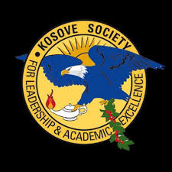

Board Meeting Notes
- Review Hotel Information for Alumni Retreat (August 7-9 2020)
  - Board members still waiting on more information from potential sites
  - Potential searches in the Orlando-Kissimmee area
  - Will report back as more information is obtained
- Updates to Diversity Advisory Committee
  - Potential updates on Term Limits, Background Diversity of Board Members, Recent Graduates
  - Need to Check with Angela on Bi-laws
- Kosove Board Documents and Vote for 2019-2020 Budget Approval
- Unanimous Approval
- Budget will be sent to Financial Office
- Reminder about Kosove Holiday Party (Sunday December 1 from 11:00 AM - 2:00 PM)
- Reflections on the recent New Kosove Scholar Induction
- Congratulations to our Four New Members!
- Distinguished Faculty Award
- Reflections on the recent On-Campus Group Service Event Keep Tampa Bay Beautiful
- 44 Foam Pieces of Trash
- 155 Glass Pieces
- 302 Plastic Pieces
- Update on Kosove Homecoming Tailgate (Saturday October 12, 2019)
- Discussed prospects of International Service trip to Belize (March 2020)
- Awaiting more information from On-Campus Group Meeting (October 4, 2019)
- Once more information is known, will forward to interested Alumni members
- Updates on Kosove Merchandise Proposal
- Met with Latoya to begin discussing logistics about group transactions

